Google Voice
Google Voice (GV) is a free service where you can get a secondary phone number that you can
- Give out to others for “your job” while protecting your personal cell number
- Use to make outgoing calls without having to block or give out your personal cell number
- Have voice messages that come in from GV converted to text messages on your phone
- Get free apps to use on your cell phone (all windows, google and Iphone)
- Schedule your ring hours for the google voice numbers

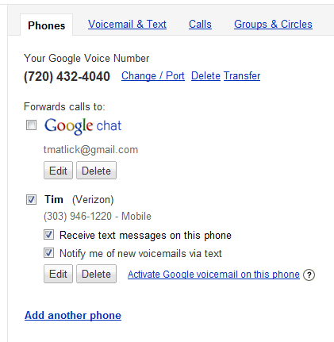
To get a free GV number go to: www.google.com/voice
During or after the sign up process, be sure to go into:
google voice setting (green arrow) phone (yellow arrow)
Set it up similar to the example on the right if you want text notifications/messages on your cell phone. This works really well when you are in classrooms or meetings. You can see the content of the message without having to make a call.

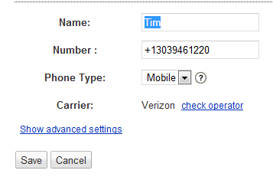
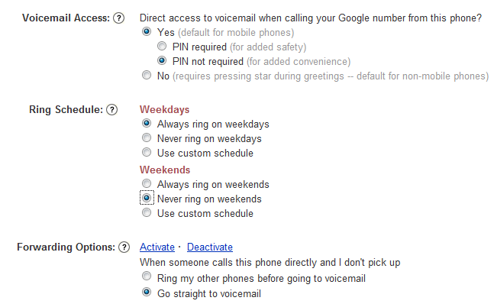
Once it is set up, you can set the “Ring Schedule” so that this number does not ring on weekend. If a parent you called during the week wants to call you on the weekend, it will go directly to voicemail. At the same time, Terry/Safety Security/other Ach Directors can still get in touch with you through your main cell number if they need to. To schedule this, click on Edit (orange arrow) and then Show advance setting (yellow arrow).

This should complete the setup of your new cell phone number. You can turn this off at any time.

Setting up your cell phone: Just download and install any of the free apps after GV is set up. The following are links to their webpages so you can read it and then look for it in your phones app store.

